Prerequisite: Fundamentals of testing and Python programming

Stage 1 - Robot Framework (Standard libraries - Builtin, String, Collections, Datetime)
Stage 2 - Robot Framework (External libraries for automation - Selenium (Web UI), Request Library (API), DB, FlaUI (Desktop automation), Appium (Android, iOS, Windows))
Stage 3 - Customized Framework (Data Driven Framework, Keyword Driven Framework, Page Object Model, Config)
Stage 4 - Git & Jenkins (only if time permits)
Stage 5 - GitHub Copilot - Gen AI

Break 1 - 11:15 AM IST
Lunch - 1 to 2 PM
Break 2 - 3:30 PM

Python and Robot Framework
- Installation
  - Python
  - Add the python.exe folder and script folder to the environment PATH variable
C:\Program Files\Python314
C:\Program Files\Python314\Scripts
  - VS Code
    - Extension
      - Python
      - RobotCode

  - Pycharm
    - Extension
      - Robotcode
  - Libraries - Based on requirement
    - pip install robotframework

- Python Architecture
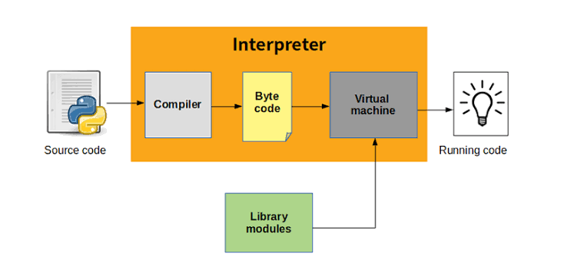
- Create Python Project
  - Create package
    - Create Python module (.py)
- To activate virtual env in pycharm/vs code terminal
.\.venv\Scripts\activate.ps1

- Python datatypes
  - Numeric - int, float
  - Sequence - String, List, Tuple
  - Dictionary
  - Boolean
- Methods - building block of the program
  - Reuse
  - Maintenance
Understand -
- how to create methods in a module (.py)
- How to call methods in a module (.py)

Robot Framework
- Setup of Robot Framework
Use (.venv)
pip install robotframework
- Standard libraries
  - Builtin
  - DateTime
  - String
  - Collections
- Sections
  - Settings
  - TestCases
  - Keywords
  - Variables
- Variable
  - Scalar ($)
  - List (@)
  - Dictionary (&)

SELENIUM LIBRARY
- Selenium Library install -
pip install --upgrade robotframework-seleniumlibrary
- Keyword doc - https://robotframework.org/SeleniumLibrary/SeleniumLibrary.html
- Selenium Architecture (WebDriver)
Source code (Python+WebDriver library) → driver → browser

- Click, type, select
- To inspect → tag name, attribute, text
- Basic locators
  - id
  - Name
  - Tagname
  - Classname
  - Linktext
  - Partial link text
When there are duplicate locators, selenium will pick the first locators

- Advance Locator
  - XPath
  - CSS
- For page load - wait for page load to complete
- All locators - should be present within 0.5s (500ms)
- Click - the element should be present and visible
- Dropdown
  - With select tag
    - Select From List By Label
    - Select From List By Value
    - Select From List By Index
  - Without select tag
- Synchronization
  - Unconditional wait (Built-in library) (not recommended)
    - Sleep 5s → not recommended (wait always for 5s)
  - Conditional wait (Selenium library)
    - Implicit wait
      - Default implicit wait - 0s
      - Applicable for all find_element (Get WebElement) and find_elements (Get WebElements)
      - Example: Implicit wait - 30s
        - If the element is not present, it will check for 30s and then throw an exception
        - If the element is present, it will proceed with the operation immediately
        - Polling time - 0.5s (how frequently it checks for element)
    - Explicit wait
      - Exact conditions

- Multiple tabs/windows
  - Switch window ( title or URL)
  - Switch window (New and Main)
    - New - the latest opened window is selected
    - MAIN - the main window is selected.
- Close browser vs close window
  - Close window - close the current tab/window
  - Close browser - close the browser, and it will also kill the process associated with it
- [Setup], [Teardown] - applied locally to the test case
  - [Setup] - runs before each test
  - [TearDown] - runs after each test, even though the test fails.
- Settings
Test Setup Open Browser browser=chrome
Test Teardown Run Keywords Close Browser AND Log To Console done

Test Setup - runs before each test method
Test teardown - runs after each test method, even if there's a failure.

Suite Setup Open Browser browser=chrome
Suite Teardown Run Keywords Close Browser AND Log To Console done

Suite setup - runs before first testcase in robot suite file

Suite teardown - runs after last testcase in robot suite file

- Frame - embedding one HTML into another HTML
  - Even though the XPath is correct, we get no locator found error
  - Check for frame or iframe
  - Switch to frame - xpath
- Alert
  - Javascript alert
- Update on Link and partial link locator
# when using link or partial link - use the font present on the UI
# better use xpath - //a[text()='Calculate Fee'] when different font in html and UI
- Upload
- CSS selector
- Mouse/Keyboard activities
- For debugging (pause screen for debugging)
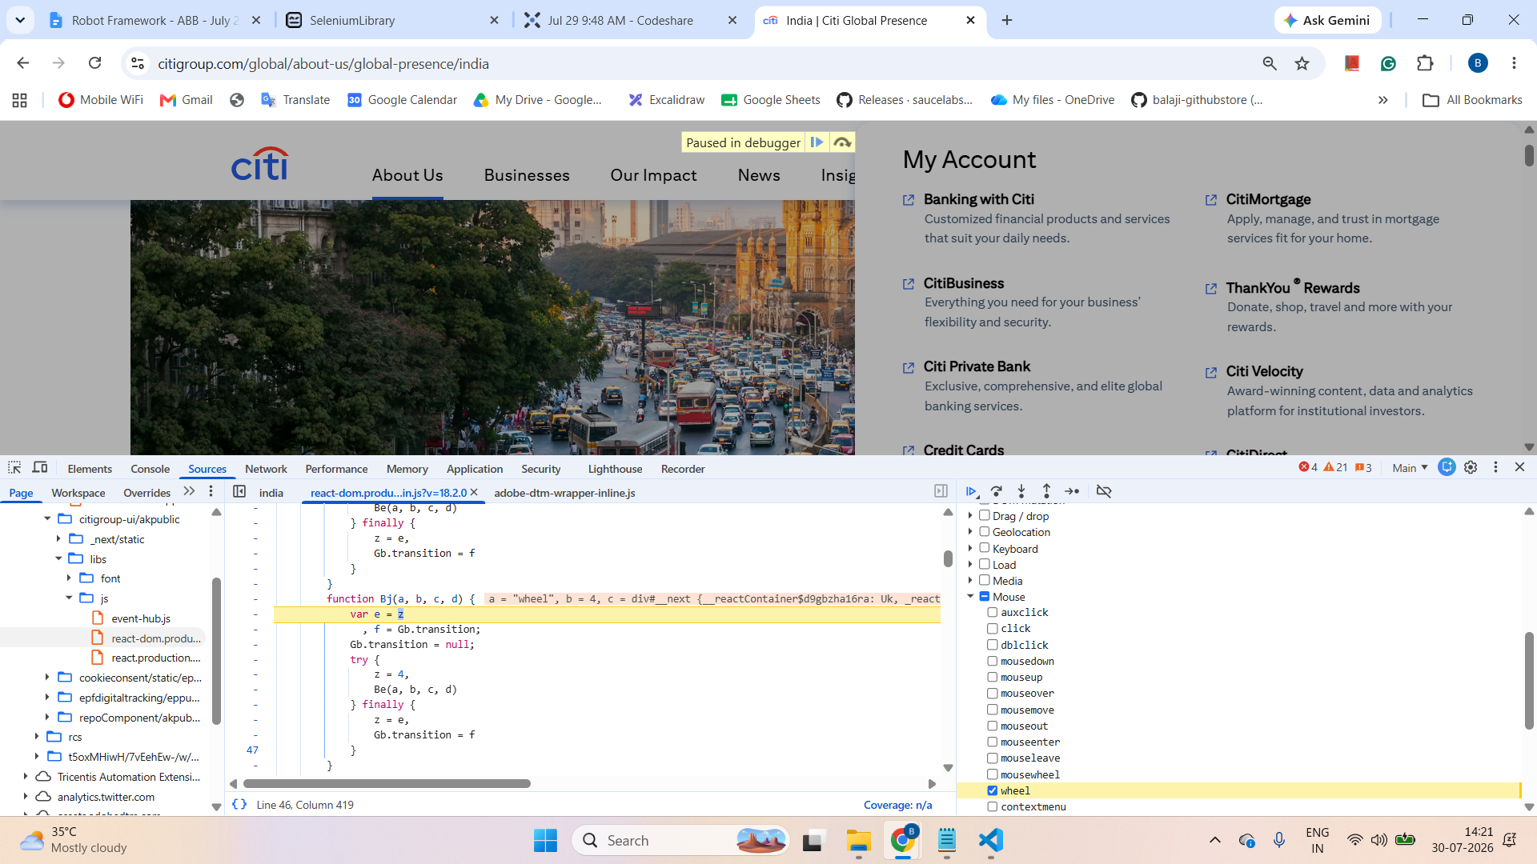
- Options - browser configuration, pre-setup
Open Browser browser=chrome options=add_argument("start-maximized");add_argument("--disable-notifications")

- JavaScript (when Selenium doesn’t support it, then only JavaScript is used to bypass the scenario in the automation pipeline)
  - Click on hidden elements
  - Type on read-only textbox
  - Scroll page, element

Option 1: Complete javascript - click() and type()
document.querySelector('#authUser').click()
document.querySelector('#authUser').value="05 Aug 2025"

Option 2: WebElement and JavaScript

${dep_element} Get WebElement xpath=//div[@id='multi-city']//input[@aria-label="Depart"]
Execute Javascript arguments[0].value="20 Aug 2026" ARGUMENTS ${dep_element}

${ret_element} Get WebElement xpath=(//div[@id='multi-city']//input[@aria-label="Depart"])[2]
Execute Javascript arguments[0].value="20 Sep 2026" ARGUMENT

HTTP RequestsLibrary (Python)

- Install
pip install robotframework-requests

- Keyword doc - https://marketsquare.github.io/robotframework-requests/doc/RequestsLibrary.html

- Base url - https://petstore.swagger.io/v2
- HTTP Methods - Get, Post, Put, Patch, Delete
- Get Request
  - Path parameter
  - Query parameter
- Get Request - Find pet by ID using Postman - example for path parameter
  - /pet/{petid} → resource

—-------------------------------------------------------------------------------------------------

Git

Git - Git is a free and open source distributed version control system.

Architecture:

Project (on local machine) → local repo (on local machine) → remote repository (GitHub, GitLab, Bitbucket, AWS CodeCommit)

Strategy | Match based on | Example
id | Element id. | id:example
name | name attribute. | name:example
identifier | Either id or name. | identifier:example
class | Element class. | class:example
tag | Tag name. | tag:div
xpath | XPath expression. | xpath://div[@id="example"]
css | CSS selector. | css:div#example
dom | DOM expression. | dom:document.images[5]
link | Exact text a link has. | link:The example
partial link | Partial link text. | partial link:he ex
sizzle | Sizzle selector deprecated. | sizzle:div.example
data | Element data-* attribute | data:id:my_id
jquery | jQuery expression. | jquery:div.example
default | Keyword specific default behavior. | default:example

Exceptions:
- No locator found -
- ElementClickInterceptedException→ some popup hides the target element
- Element not interactable → element is present not visible (mouse over or scroll)

Day 1

Task 1
1. Navigate onto https://www.medibuddy.in/
2. Close if any popup and Click on Login
3. Click on I have Corporate Account
4. Click on Learn More
5. Click on Skip
6. Click on Login using Username & Password
7. Enter username as john
8. Enter password as john123
9. Click on show password
10. Click log in
11. Get the error message shown and print it in terminal

Task 2
1. Navigate onto https://nasscom.in/
2. Click on Login and then click on register
3. Enter First name as admin
4. Enter Last name as pass
5. Enter email address as admin@gmail.com
6. Enter company name as Google
7. Select IT Consulting from dropdown
8. No need to automate CAPTCHA
9. Click on Register

Day 2:

Task 1 (Important)
- Navigate onto https://www.online.citibank.co.in/
- Click on My account
- Click on banking with citi
- Fill form userid and click login
- Validate error message

Task 2 (Important)
1. Navigate onto http://demo.openemr.io/b/openemr/
2. Update username as admin
3. Update password as pass
4. Select language as English (Indian)
5. Click on the login button
6. Click on Patient Click New Search
7. Add the first name, last name
8. Update DOB as today's date
driver.findElement(By.id("form_DOB")).sendKeys("2024-01-12");
9. Update the gender
10. . Click on the create new patient button above the form
11. . Click on confirm create new patient button.
12. . Print the text from alert box (if any error before handling alert add 5 sec wait)
13. . Handle alert
14. Close the Happy Birthday popup
15. Get the added patient name and print in the console.

—------------------------------

@{client certs}= create list ${cert_path} ${key_path} Create Client Cert Session alias=${alias} url=${url} client_certs=${client certs} verify=${False}

